1. Write a paragraph proof.

Given: ∠T and ∠V are right angles.
Prove: ∆TUW ∆VWU
​
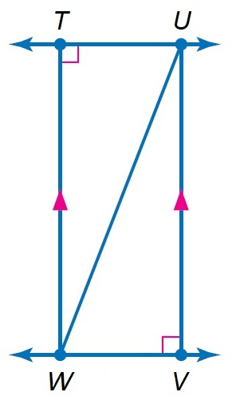

∆TUW ∆VWU
The triangles are congruent due to the following reasons Hypotenuse, Leg rule. They share the hypotenuse meaning that they have equal hypotenuse. Also, the legs are equal in length. That is WV=TU. Secondly, Side, Side and Side rule. In this case, the corresponding sides of both triangles are equal. WV=TU, TW=VU and now the hypotenuse WU which they both share. Angle, Angle, and Side: both Angle T and angle V are right angled triangle.

2. Sled kites rely on wind pressure to retain the shape of the sail. Each consists of a single square and two triangular pieces. Kyle has made a model of a Sled kite as shown below. Show that the angles and are congruent.
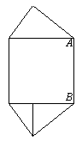

The shape in which the two angle are is a square which means that all interior angles in the corners of a square are right angles. Thus and =90º Hence they are congruent.

3. A ray of light is reflected when it hits a mirror. The angle at which the light strikes the mirror is the angle of incidence, i. The angle at which the light is reflected is the angle of reflection, r. The angle of incidence and the angle of reflection are congruent. In the diagram below, if , what is the angle of reflection and
​
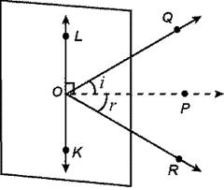
Solution:

Given:
i=r
Angle POL=POK= 90º

To get
124= i+r
R= 124- i
But i= 124/2
= 62.
Now r=62
= 90-r
= 90-62
= 28º
Thus =28

4. Samantha has cut a pastry into four parts. Suppose and T is the midpoint of PR. Determine whether
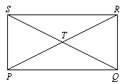
Solution:
If and T is the midpoint of PR, Then we know the following
PT=RT, ST=TQ, and SP=RQ
Also, angle STP =angle RTQ, angle TRQ=angle TPS for they are alternative angles. Also, angle TQR=angle TSQ for they are also alternative angles.
Thus Due to Side, Side and Side rule and Angle, Angle Side rule where the included side is TP and TR

5. A pathway divides a rectangular garden into two parts as shown. Find the measure of
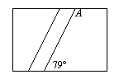
Solution:
Angle A= 180-79
= 101º
This is due to the fact that the lengths of a rectangle are parallel to each other and they give alternate angles. SO 101o is alternate angle to Angle A.

6. Andy was playing a memory game with his sister. He turned over a tile to reveal a picture of the sun at the coordinates (5, 4). He looked under a tile that was 3 units to the left and 2 units down but revealed a picture of a tree. His sister knew that the other sun was 1 unit to the left and 1 unit up from the tree. What are the coordinates of the second sun?
Solution:
First we determine the coordinates of a tree.
We are told, the coordinates of the first sun is (5, -4)
From this point, three units to the left is given by : 5-2=2
Also, two units downward is given by: -4- (2)= - 6

Thus, the coordinate of picture of a tree are at (2, -6)

Now from this point we can determine the position of the second sun.
The second sun is at point at 1 unit to the left and 1 unit up from the tree
In this case we subtract one unit from each axis. i.e
x-axis: 2-1=1
y-axis: -6+1= -5

hence the coordinate of the second sun is (1, -5)

7. Carpenters use parallel wall studs to build support for walls. A carpenter has built two wall studs given by HG and CD in the figure below. Find the measure of so that the two wall studs are parallel.
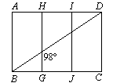
For walls to be parallel, the following has to be met:
- AD should be parallel to BC
- Angle ADB should be equal to angle DBC fo alternitivity.
- Since GH is a straight line, its angle should sum up to 180º. and angle BDC = 180-98= 82º

Thus angle BDC=82^{O}

8. Richard ordered a coffee table that was a regular pentagon. Find the measure of an exterior angle of the table.
Solution:
All the interior angles of vertices in the regular polygon must be equal and must add up to 360º.
Thus each interior angle of a pentagon is:
=360/5
= 72º
The exterior angle is given by
= 180-72
= 108º
9. Let be the median of LMBA. Find,, and .

Use trapezoid ABCD to find each measure.
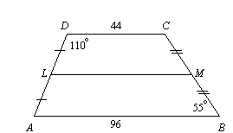

= m angle LDC=110º

= 180-110= 70º
To get JK, we have to get LM first.
LM= ½(44+96)
= 70
JK is the median of LMBA
JK= ½ (70+96)
= 83

10. In a museum, Nick is looking at a famous painting through a mirror at an angle of Find the angle the painting makes with the mirror. Also find and
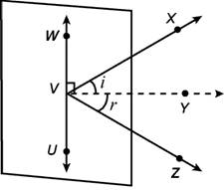
Solution
- The angle of incident is equal to the angle of reflection. i.e
i=r
That is i=r=58º
Thus, the painting make 58º with the mirror

- Find
- = i+r
= 58 +58
= 116º

- Find
= Angle YVW- i but angle YVW=90
= 90-58
= 32º
11. If a bike tire has 16 spokes spaced evenly apart, name its angles of rotation.
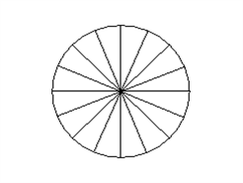

angle of rotation= 360/16
= 22.5º

12. Richard wants to buy a LCD flat panel monitor measuring 14 inches by 16 inches. What is the measure of the diagonal of the monitor?
Solution
Let the width of the LCD w=14 inches
And the length be l=16 inches
To get the diagonal we use Pythagoras theorem
Diagonal = (l² + w²) ^{½}
= (16² + 14²) ^{½}
= 21.26 inches

13. Samantha’s rectangular gift is 10 inches. by 12 inches and is framed with a ribbon. She wants to use the same length of ribbon to frame a circular clock. What is the maximum radius of the circular clock? Round to the nearest whole number.

Solution
The total length of rectangular gift is = 10 x 2 + 12 x 2
= 44 inches

The circumference of a circle is given by : 2r x 22/7
In this case, 2r x 22/7= 44 inches. Were r is the radius of a circle
Now, to get r,
r= (44 x 7)/ (2 x22)
= 7 inches

Write a two-column proof.

14. Given: is the perpendicular bisector of
Prove:
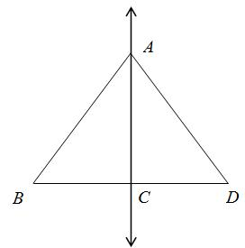

Statement | proof
- ┴ | Given
- BC = CD | The bisector divides BD into two
- Side AB = Side AD | They share a common Opposite side and equal bases
- Triangle ABC is congruent to triangle ADC | Side, Side angle
 | The two sides AB and AD of triangle BAD are congruent

15. Write a flow proof for the problem.
Given:
Prove:
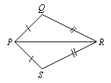

Write a two-column proof.

Statement | proof
 | Given
- Angle PQR is congruent to angle PSR | They share a common base PR, and sides PS=PQ, and QR=SR
- Angle, Angle side. | Angle PRS and angle PRQ are congruent, also angle RPS and angle RPQ are congruent and the included side is PR
- Hence

16. Find the coordinates of the orthocenter of ΔYAB that has vertices at Y(3, –2), A(3, 5), and B(9, 1).
Solution

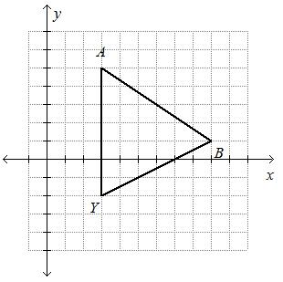
Solution:
Getting slope for side A-B and for side BY

M1 = (1-5)/(9-3)= -2/3
M2= (1--2)/(9-3)= ½
Second we get the slope of perpendiculars on the opposite altitude to these vertices
M3= -1 / (-2/3)= 3/2
M4= -1/ (1/2)= -2

We get the equations for this perpendiculars
y_{o} = mx+ c
the first equation, we will use the coordinates fro point B
thus:
1= 9 (3/2) +c
To get the value of C
C = 1- 27/2= -12.5
Substituting the value of C in the above equation we get
Yo= 3/2 (x) – 12.5
Third we get the equation for slope M4
Y1=mx + C
Using the coordinates for point Y
-2= -2(3) + C
C= 4
Substituting the value of C in Y1
Y1= -2x +4
Now, the orthocenter of triangle ABY is at the point of intersection of these two equations.
Thus at the point of intersection, they are both equal
Y1=Yo
Hence,
-2x + 4 = 3x/2 – 12.5
Solving for x
X(-2 – 3/2)= -12.5 -4
X= -16.5 x – 2/7 =31/7

Substituting x to one of the equation, say Y1, we get:
Y= -2 (31/7) + 4
Y= 34/7
Thus the coordinates for orthocenter is (31/7, 34/7)

17. For isosceles trapezoid ABCD, find the length of the median and .(JUSTIFY)
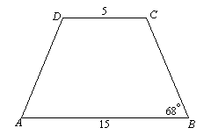

Solution:
Median = ½ (5+15)
= 10
= 68º reason: the angles formed at the bases of isosceles trapezoid are equal
18. Write a two-column proof.
​
Given:
and are rt.
Prove: ∆ABC ∆ADC

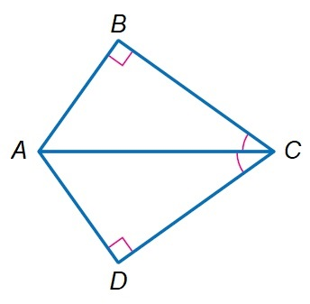
statement | proof
 | Given
- and are rt. | Given
- Angle, Angle Side | Angle D=angle B, angle and length AB=AD
- Hence ∆ABC ∆ADC

19. A salesperson travels from city A to city B and then to city C. From city C, the salesperson travels directly back to city A as shown in the diagram below. Write the lengths of the legs of the trip in order from least to greatest.
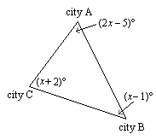
Solution
First we determine the value of xº
In this case, the sum of all angles =180º
Thus; (x+2) +(2x-5)+(x-1)=180
4x-4= 180
X=46
Now the angles at each city are
A= 2x46-5=87º
B= 46-1 =45º
C= 46 +2= 48^{O}
the lengths of the trip from the least to the greatest
- From city C to A-least
- From city A to B- second least
- From city B to C- greatest trip

20. A construction manager moved a shed to the back corner of a lot. Because there were so many trees in the way, the construction manager had to move it 6 units up, 2 units to the left, 2 units down, and 3 units to the left. The vertices are now (5, 5), (0, 5), (5, 3), and (0, 3). What were the original vertices of the shed?

Solution
The final coordinates of the shed are (5, 5), (0, 5), (5, 3), and (0, 3).
Starting from this position, we will turn back until we reach where the original position of shed was.
- Now, the last move was 3 units to the left. So we will turn the shed 3 units to the right and we get the coordinates
As: (2, 5), (3, 5), (2, 3), and (3, 3).
- Second last move was 2 units down. So we will have 2 units up
And the coordinates become: (2, 7), (3, 7), (2, 3), and (3, 3).
- Third, the shed was moved 2 units to the left. So we add 2 units to the right. Thus
: (0, 7), (5, 7), (0, 3), and (5, 3).
- Lastly, the shed was move 6 units ups, so we move it 6 units down to have the original coordinates.
: (0, 1), (5, 1), (0, -1), and (5, -1).

